**Chapter 4**

**Differentiation of Functions of Several Variables**

**4.8 Lagrange Multipliers**

**Section Exercises**

**For the following exercises, use the method of Lagrange multipliers to find the maximum and minimum values of the function subject to the given constraints.**

1. 

Answer: maximum: minimum: 

1. 

Answer: maximum:  minimum: 

1. 

Answer: maximum: minimum: 

1. 

Answer: maximum: minimum: 

1. 

Answer: maximum:  minimum:

1. 

Answer: maximum: minimum = 

1. 

Answer: maxima: minima:  

1. 

Answer: maxima:   minima:  

1. 

Answer: maximum:  at  minimum:  at

1. 

Answer: maximum:  at  minimum:  at 

1. 

Answer: Minimum:  at  There is no upper bound.

1. Minimize  on the hyperbola

Answer: 

1. Minimize  on the ellipse 

Answer: 

1. Maximize  on the sphere

Answer: 

1. Maximize 

Answer: The maximum is  at .

1. The curve  is asymptotic to the line Find the point(s) on the curve farthest from the line 

Answer: 

1. Maximize 

Answer: maximum:  at 

1. Minimize 

Answer: 

1. Maximize 

Answer: 

1. Minimize 

Answer: 

1. Minimize  subject to the constraint 

Answer: minimum: 

1. Minimize  when  and 

Answer: minimum: 

**For the next group of exercises, use the method of Lagrange multipliers to solve the following applied problems.**

1. A pentagon is formed by placing an isosceles triangle on a rectangle, as shown in the diagram. If the perimeter of the pentagon is  in., find the lengths of the sides of the pentagon that will maximize the area of the pentagon.

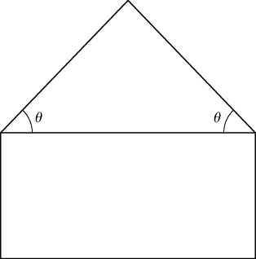

Answer: 

1. A rectangular box without a top (a topless box) is to be made from  ft2 of cardboard. Find the maximum volume of such a box.

Answer: The maximum volume is  ft3. The dimensions are ft.

1. Find the minimum and maximum distances between the ellipse  and the origin.

Answer: The maximum is The minimum is

1. Find the point on the surface  closest to the point 

Answer: 

1. Show that, of all the triangles inscribed in a circle of radius  (see diagram), the equilateral triangle has the largest perimeter.

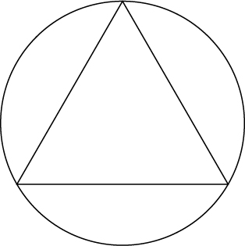

Answer: Answers vary.

1. Find the minimum distance from point  to the parabola

Answer: 

1. Find the minimum distance from the parabola  to point

Answer: 

1. Find the minimum distance from the plane  to point

Answer: 

1. A large container in the shape of a rectangular solid must have a volume of  m3. The bottom of the container costs $5/m2 to construct whereas the top and sides cost $3/m2 to construct. Use Lagrange multipliers to find the dimensions of the container of this size that has the minimum cost.

Answer: 

1. Find the point on the line  that is closest to point 

Answer: 

1. Find the point on the plane  that is closest to the point 

Answer: 

1. Find the maximum value of  where  denote the acute angles of a right triangle. Draw the contours of the function using a CAS.

Answer: 

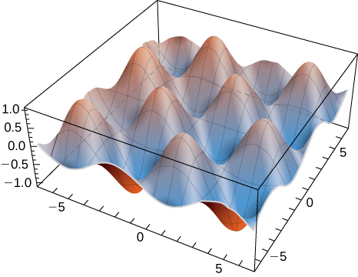

1. A rectangular solid is contained within a tetrahedron with vertices

at  and the origin. The base of the box has dimensions  and the height of the box is If the sum of  is 1.0, find the dimensions that maximizes the volume of the rectangular solid.

Answer: 

1. **[T]** By investing *x* units of labor and *y* units of capital, a watch manufacturer can produce  watches. Find the maximum number of watches that can be produced on a budget of  if labor costs $100/unit and capital costs $200/unit. Use a CAS to sketch a contour plot of the function.

Answer: Roughly 3365 watches at the critical point 

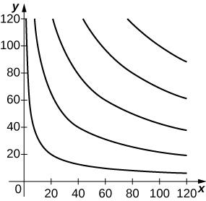

**Chapter Review Exercises**

**For the following exercises, determine whether the statement is *true or false*. Justify your answer with a proof or a counterexample**.

1. The domain of  is all real numbers, and

Answer: False, 

1. If the function  is continuous everywhere, then 

Answer: True, by Clairaut’s theorem

1. The linear approximation to the function of  at  is given by 

Answer: False

1.  is a critical point of 

Answer: False

**For the following exercises, sketch the function in one graph and, in a second, sketch several level curves.**

1. 

Answer: Answers may vary

1. 

Answer: Answers may vary

**For the following exercises, evaluate the following limits, if they exist. If they do not exist, prove it.**

1. 

Answer: 

1. 

Answer: Does not exist

**For the following exercises, find the largest interval of continuity for the function.**

1. 

Answer: Continuous at all points on the except where .

1. 

Answer: Continuous at all points on the  except where  .

**For the following exercises, find all first partial derivatives.**

1. 

Answer: 

1. 

Answer:     

**For the following exercises, find all second partial derivatives.**

1. 

Answer:    

1. 

Answer:         

**For the following exercises, find the equation of the tangent plane to the specified surface at the given point.**

1.  at point 

Answer: 

1.  at point 

Answer: 

1. Approximate at  Write down your linear approximation function  How accurate is the approximation to the exact answer, rounded to four digits?

Answer:    error: 

1. Find the differential  of  and approximate  at the point  Let and

Answer:  

1. Find the directional derivative of  in the direction 

Answer: 

1. Find the maximal directional derivative magnitude and direction for the function  at point 

Answer: 

**For the following exercises, find the gradient.**

1. 

Answer: 

1. 

Answer: 

**For the following exercises, find and classify the critical points.**

1. 

Answer:  is a local minimum;  is a saddle point.

**For the following exercises, use Lagrange multipliers to find the maximum and minimum values for the functions with the given constraints.**

1. 

Answer: maximum: minimum: 

1. 

Answer: maximum: none, minimum: 

1. A machinist is constructing a right circular cone out of a block of aluminum. The machine gives an error of  in height and  in radius. Find the maximum error in the volume of the cone if the machinist creates a cone of height  cm and radius  cm.

Answer: cm3

1. A trash compactor is in the shape of a cuboid. Assume the trash compactor is filled with incompressible liquid. The length and width are decreasing at rates of  ft/sec and  ft/sec, respectively. Find the rate at which the liquid level is rising when the length is  ft, the width is  ft, and the height is ft.

Answer: The height is increasing at a rate of  ft/sec.

This file is copyright 2016, Rice University. All Rights Reserved.